**==========================================================**

**Windows forms Application**

**Ted Shop Management**

=====================================================================================

**Goals:**

The goal is to develop a Windows Forms Application “Ted shop system.

**System description:**

Your system must have the three main functions:

1. Order products
2. Delivery products
3. Display sold products

**Your program output may be look like:**

1. **Main screen**

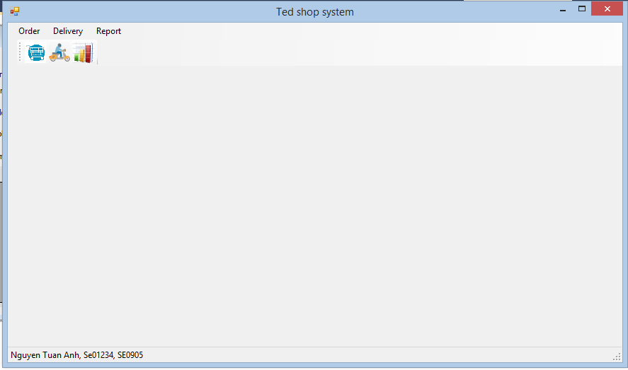

Requirements:

* Menu: 3 menu items: Order, Deliver, and Report.
* Tool bar: 3 buttons: Order, Deliver, and Report.
* Status bar: Student’s name, student’s ID, and class ID.

# Order products screens

Transition flow for order products screens:

Checkout

Order

Cart

Product detail

Select product

Name

Select

Detail

Cancel/Close

Close

Cancel/Close

## 2.1. Select product screen

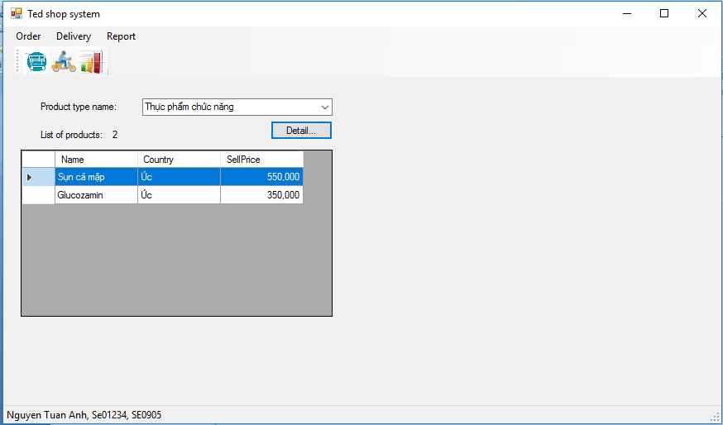

Requirements: The system displays the list of products and allows the user to select a product.

The user can:

* Select a product type from the list of product types, then the system displays the list of products of that selected product type.
* Click the button “Detail…” to open a dialog “Product detail”.

## 2.2. Product detail screen

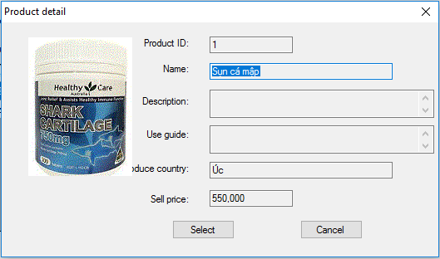

Requirements: The system displays the detail information of a product.

The user can:

* Click the button “Select” to select that product, then Cart screen will be displayed

## Cart screen

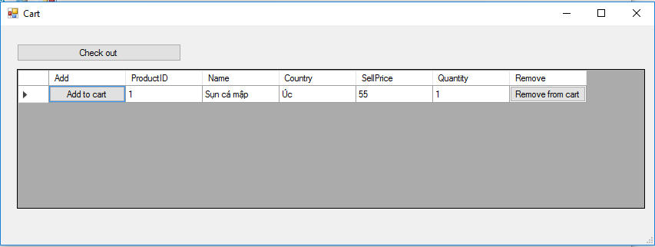

Requirements: The system displays your cart and allows the user to add/remove to/from the cart:

The user can:

* Click the button “Add to cart” to increment quantity of the selected product by 1.
* Click the button “Remove from cart” to decrement quantity of the selected product by 1.
* Click the button “Check out” to open dialog “Order”.

## Order screen

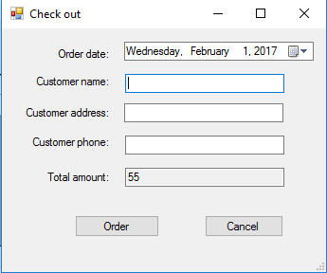

Requirements: The system displays the total amount of your cart and allows the user to order

The user can:

* Enter order date and his/her information (name, address, and phone).
* Click the button “Order” to order these products (check total amount > 0, name, address, and phone are not empty). If name/address/phone is empty, the following eror messages will be displayed:

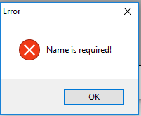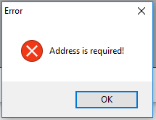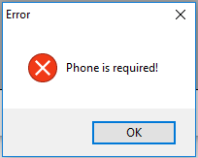

Otherwise that order will be added into Database and the following message will be displayed

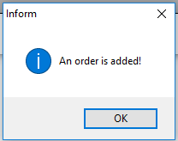

# Deliver products screen

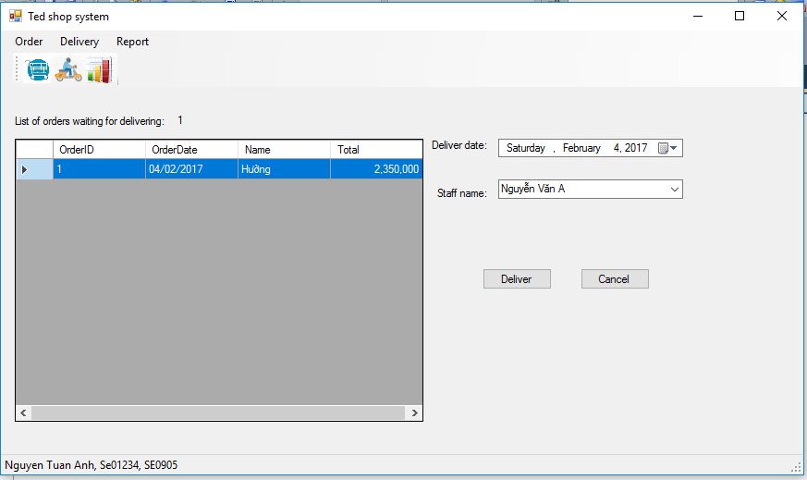

Requirements: The system displays the list of orders waiting for delivering, and allows the user to deliver

The user can:

* Select an order from the list of orders, deliver date, and staff name from the list of staff names.
* Click the button “Deliver” to deliver the selected order. The deliver information will be updated into Database , and the following message will be displayed:

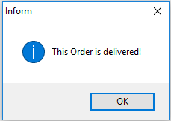

# Display sold products screen

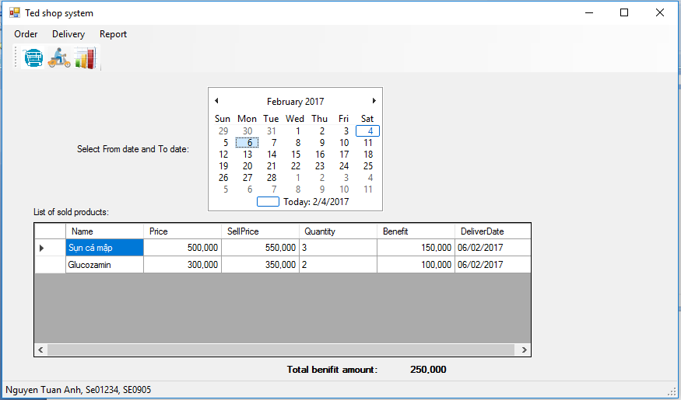

Requirements: The system displays the list of sold products for the period of time

The user can:

* Select a date range (start date to end date), then the system displays the list of sold products during that period.

Here, column “Benefit” = (SellPrice – Price) * Quantity, and Total benefit amount = sum of values of benefit column.

**General Requirements:**

* Format of amount: “#,#”.
* Format of date: “dd/MM/yyyy”.
* Your system must follow all rules described in Ted shop system .
* Your system must check input data and allow the user to enter again.
* Design the database follow all functions described in Ted Shop system.
* All functions have to working.
* Validate all entry allowed input data.
* Apply OOP design.